Analysing the Performance & Efficiency of The Radisson

Hotels using Data Visualization Techniques

1) INTRODUCTION:

1.1) OVERVIEW:

The hotel industry is a broad category of businesses that provide lodging services for travellers and tourists. This can include a wide range of establishments, from luxury resorts to budget-friendly motels, as well as extended stay hotels, boutique hotels, and more. Hotels can be found in nearly every corner of the world, and are often a major component of the tourism and travel industry in a given area. Radisson owns multiple five-star hotels across India. They have been in the hospitality industry for the past 100 years. Due to strategic moves from other competitors and ineffective decision-making in management, Radisson is losing its market share and revenue in the luxury/business hotels category. As a strategic move, the managing director of Radisson wanted to incorporate Business and Data Intelligence in order to regain their market share and revenue. Our task is to create an analytics dashboard & story to provide them insights to make better business decisions.

1.2) PURPOSE:

Most studies on performance evaluation in the hospitality industry solely focus on efficiency measurement; however, effectiveness, an integral part of organizational performance that can influence its competitive stance in the market, is ignored. Therefore, this study aims to measure the performance of Indian hotels considering both efficiency and effectiveness simultaneously using a two-phase evaluation model with panel data. The efficiency and effectiveness scores are measured using data envelopment analysis. McKinsey’s nine-cell matrix has also been deployed to show the competitive positioning of the hotels being studied. The results yield no significant correlation between the efficiency and effectiveness scores; nevertheless, there does seem to be a strong positive correlation between effectiveness scores vis a vis the overall performance of a hotel. This project helps us to understand the effective ways of hotel Radisson and its management. The things can be achieved using this project is more effectiveness in hospitality and performance of the Radisson hotels.

2) Problem definition and Design thinking:

2.1) Empathy Map:

An **empathy** map is a collaborative visualization used to articulate what we know about a particular type of user. It externalizes knowledge about users in order to 1) create a shared understanding of user needs, and 2) aid in decision making. The empathy map in analysing the problems of the Radisson hotels project visualization is shown below.

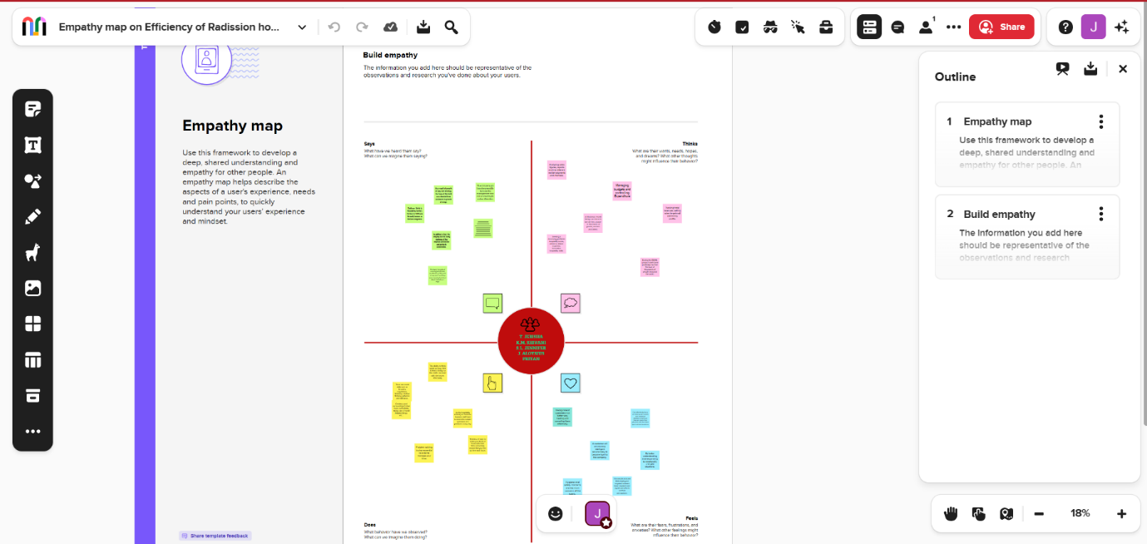

2.2) Ideation and Brainstorming Map:

Brainstorming is a group [creativity technique](https://en.wikipedia.org/wiki/Creativity_technique) by which efforts are made to find a conclusion for a specific problem by gathering a list of ideas spontaneously contributed by its members.

In other words, brainstorming is a situation where a group of people meet to generate new ideas and solutions around a specific domain of interest by removing inhibitions. People are able to think more freely and they suggest as many spontaneous new ideas as possible. All the ideas are noted down without criticism and after the brainstorming session the ideas are evaluated. The brainstorming ideas and the visualizations are made and the final image is shown below.

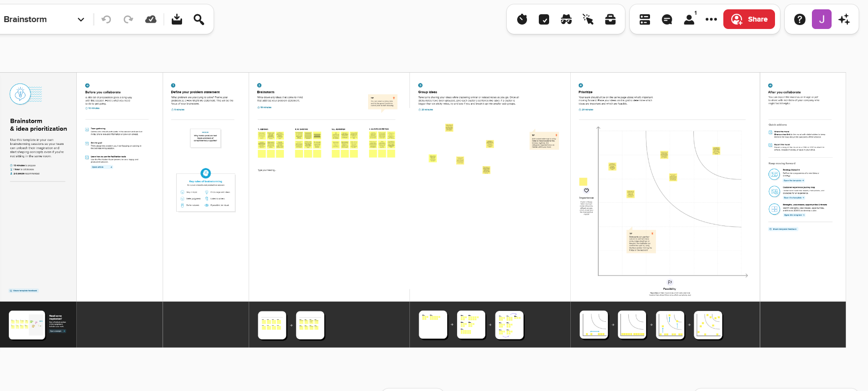

RESULT: Final findings (output)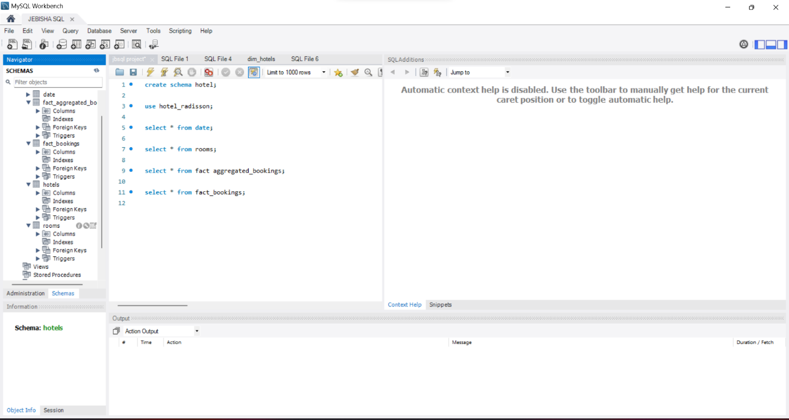

Data collection is the process of gathering and measuring information on variables of interest, in an established systematic fashion that enables one to answer stated research questions, test hypotheses, and evaluate outcomes and generate insights from the data. The above work is done in MYSQL workbench on RADISSON HOTEL ANALYSIS DATA EXTRACTION.

CONNECT DATABASE WITH TABLEAU:

DATA PREPARATION:

DATA PREPARATION FOR VISUALIZATION:

##### Tableau Desktop delivers everything you need to access, visualize, and analyses your data. With an intuitive drag and drop interface, you can uncover the hidden insights you need to make impactful business decisions faster, even when you are offline. All while leveraging trusted and governed data in a secure self-service environment.

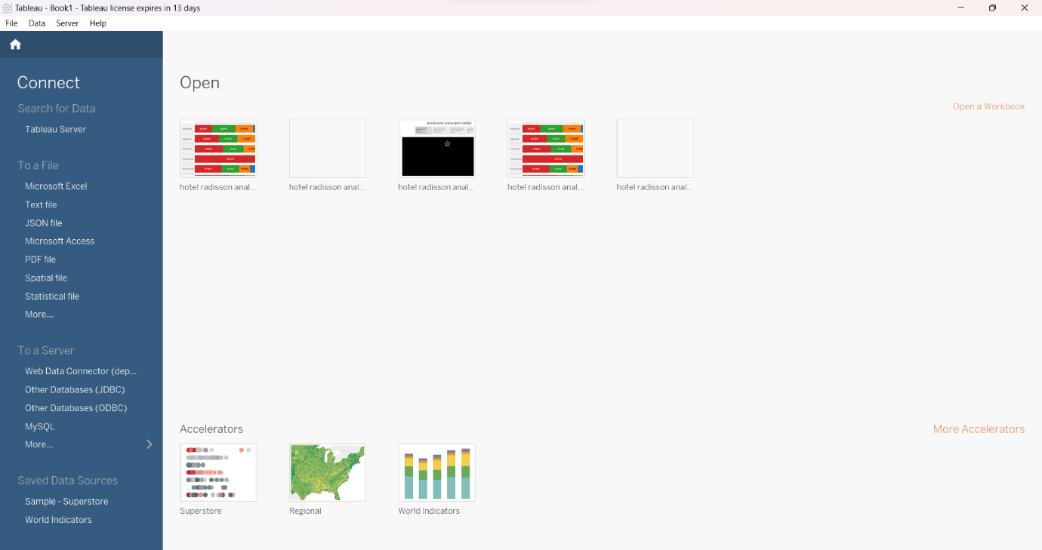

DATA VIZUALISATIONS:

NUMBER OF UNIQUE VISUALIZATIONS:

* REVENUE SPLIT BY CITY: 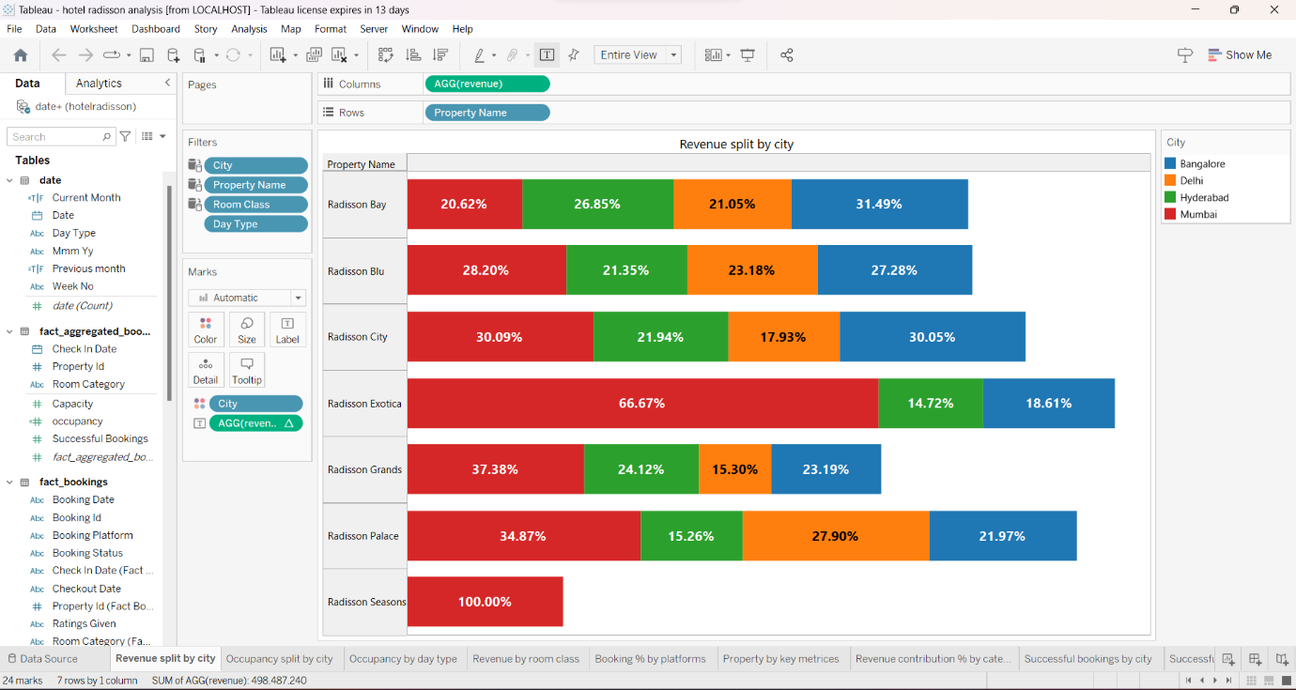
* OCCUPANCY SPLIT BY CITY: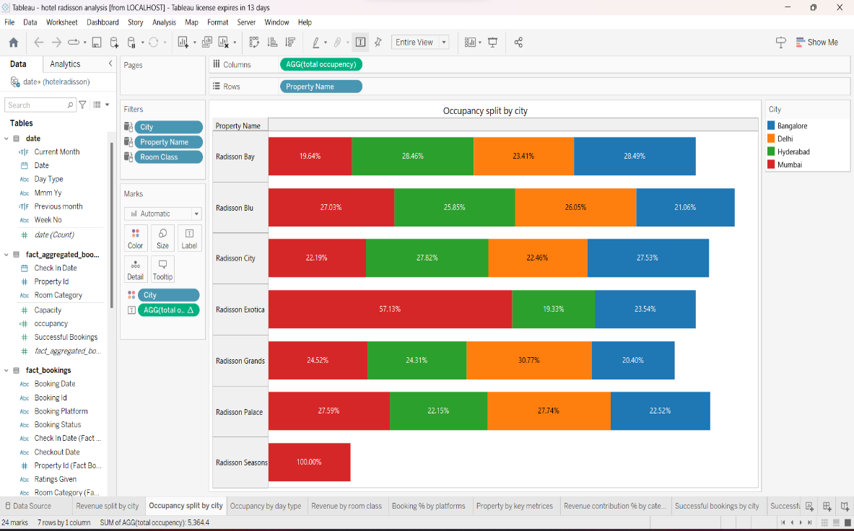
* OCCUPANCY BY DAY TYPE: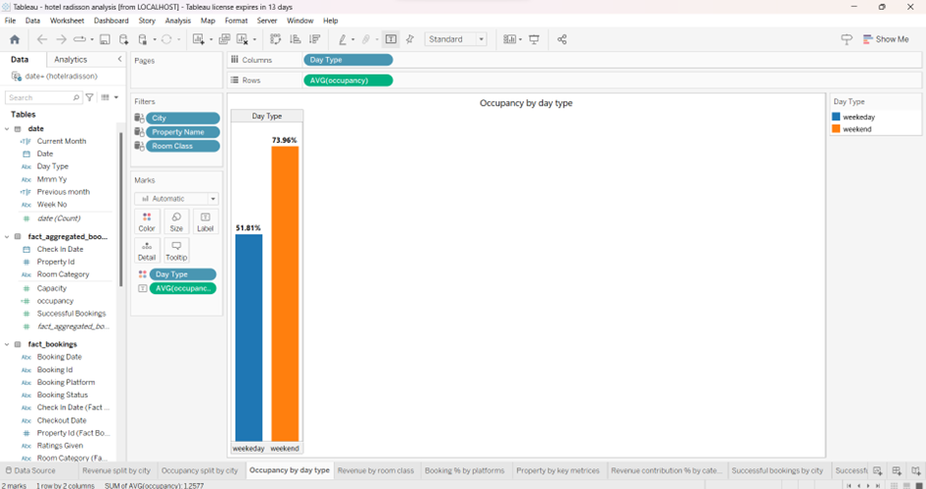
* REVENUE BY ROOM CLASS: 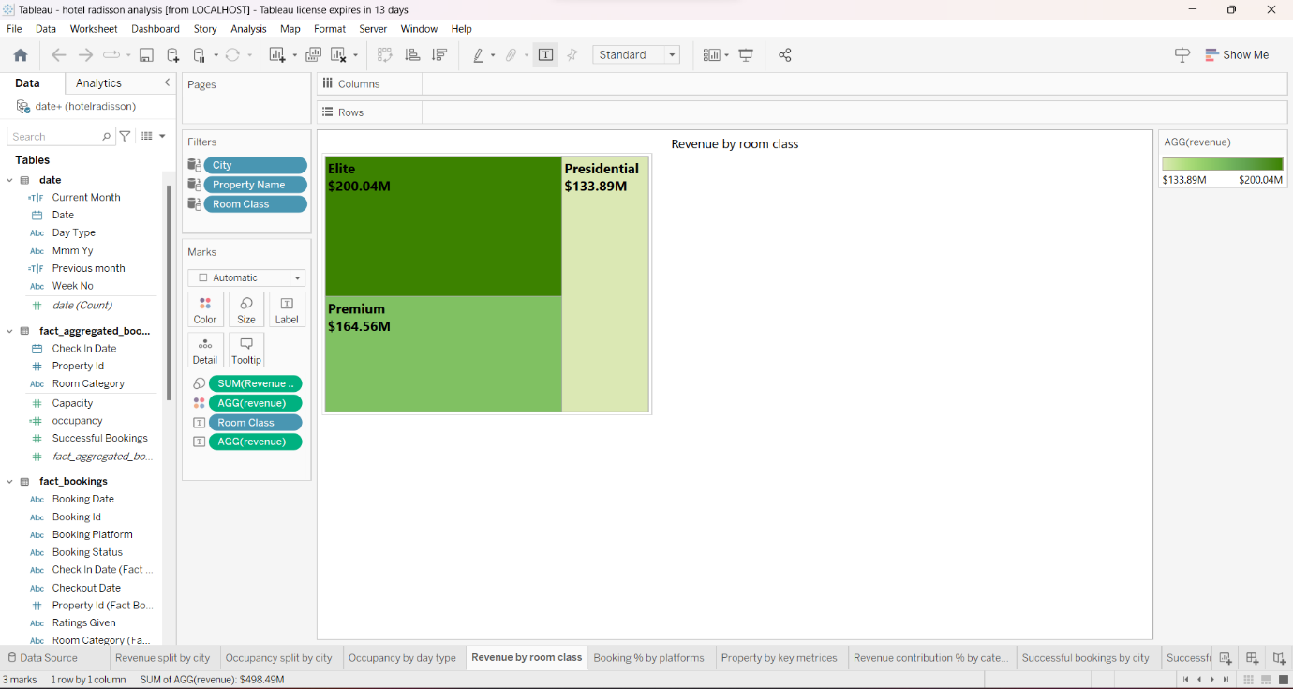
* BOOKING % BY PLATFORMS:
* 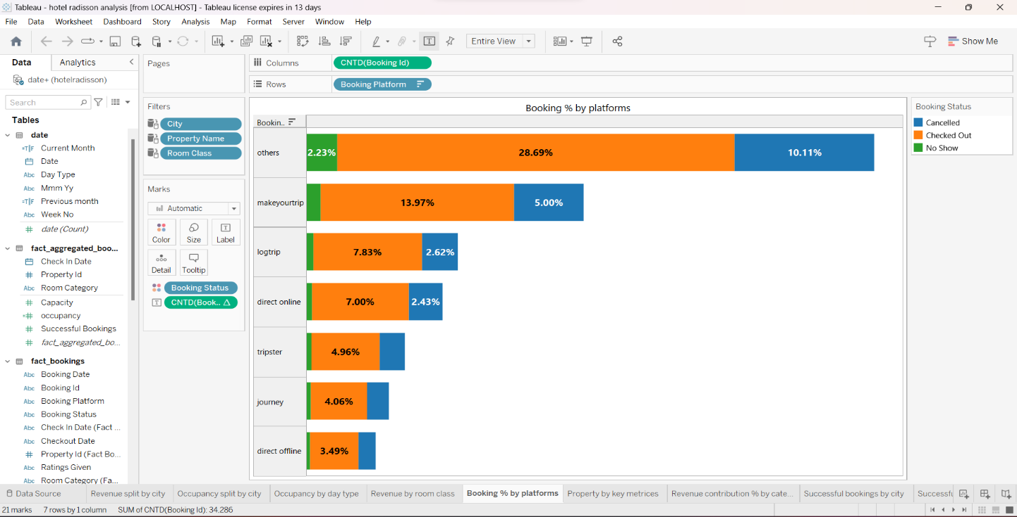
* PROPERTY BY KEY METRICES:

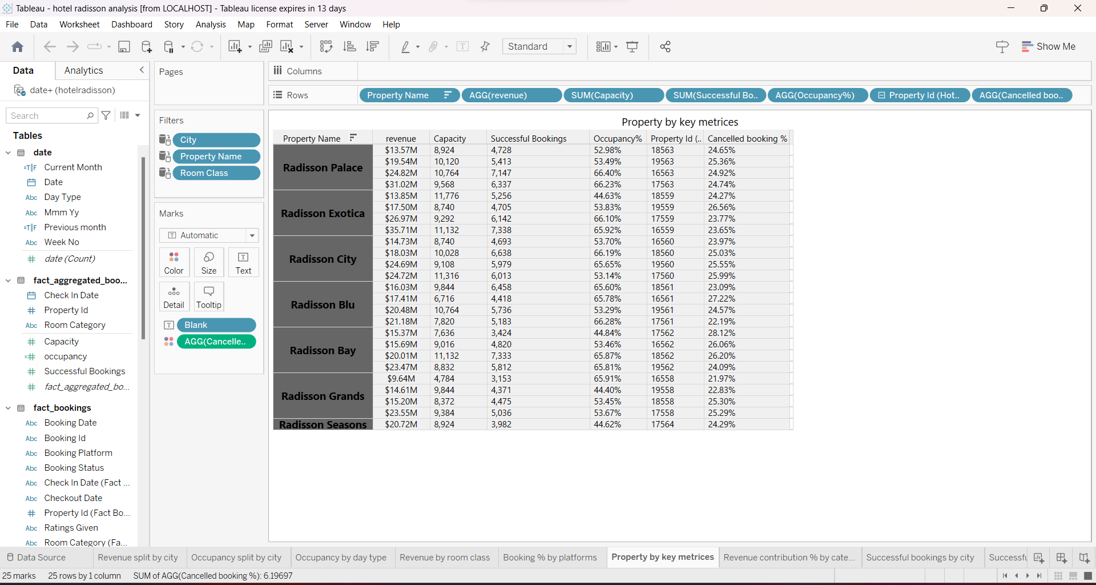

* REVENUE CONTRIBUTION % BY CATEGORY:

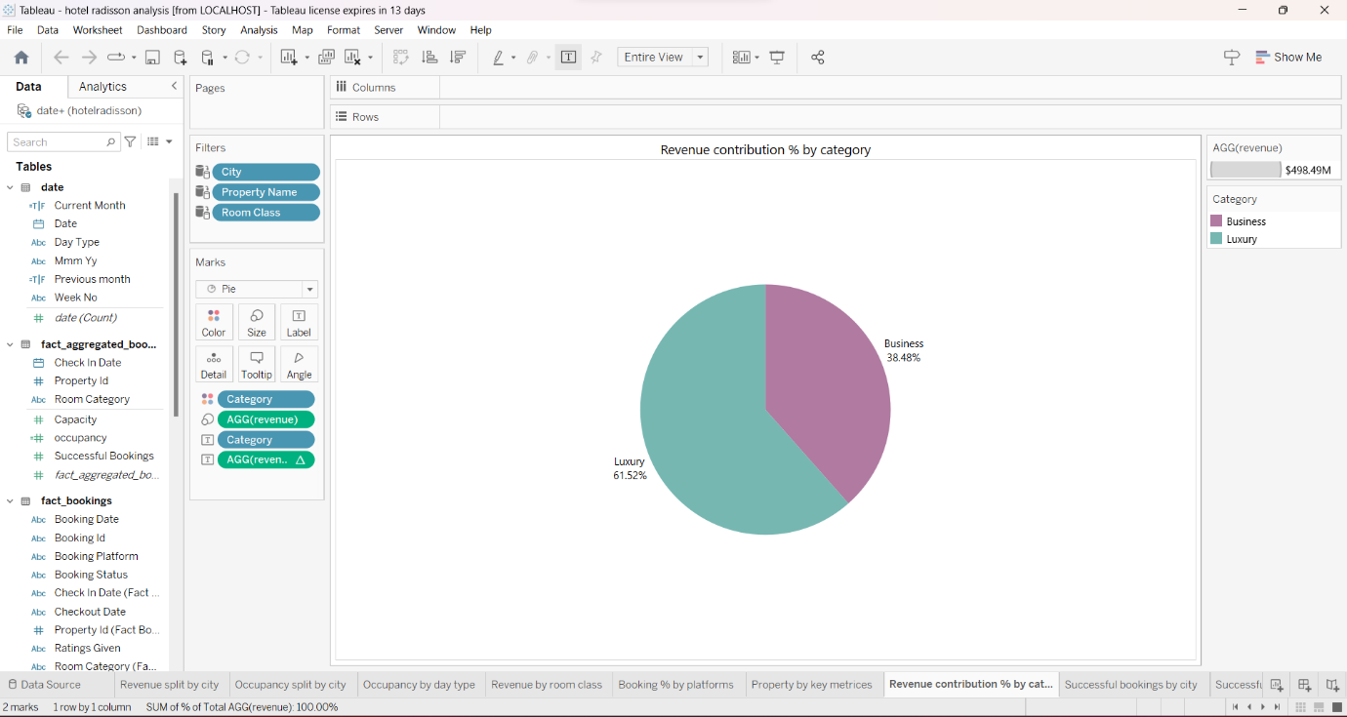

* SUCCESSFUL BOOKINGS BY CITY: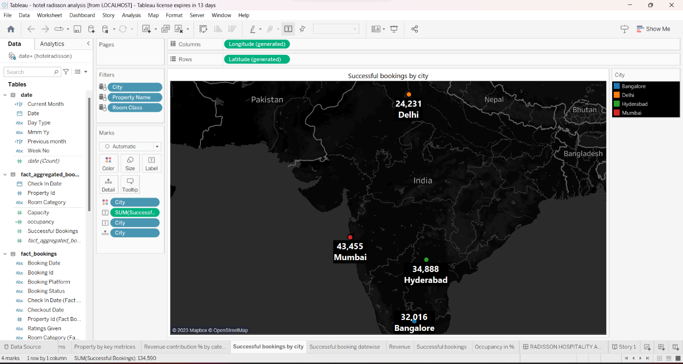
* SUCCESSFUL BOOKINGS DATE WISE:

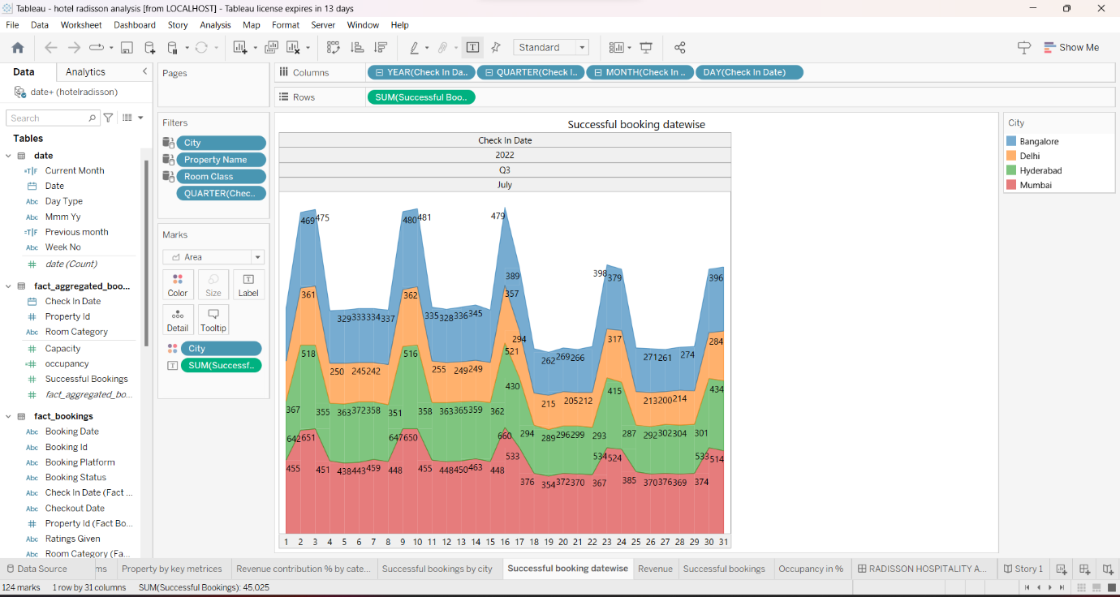

* REVENUE: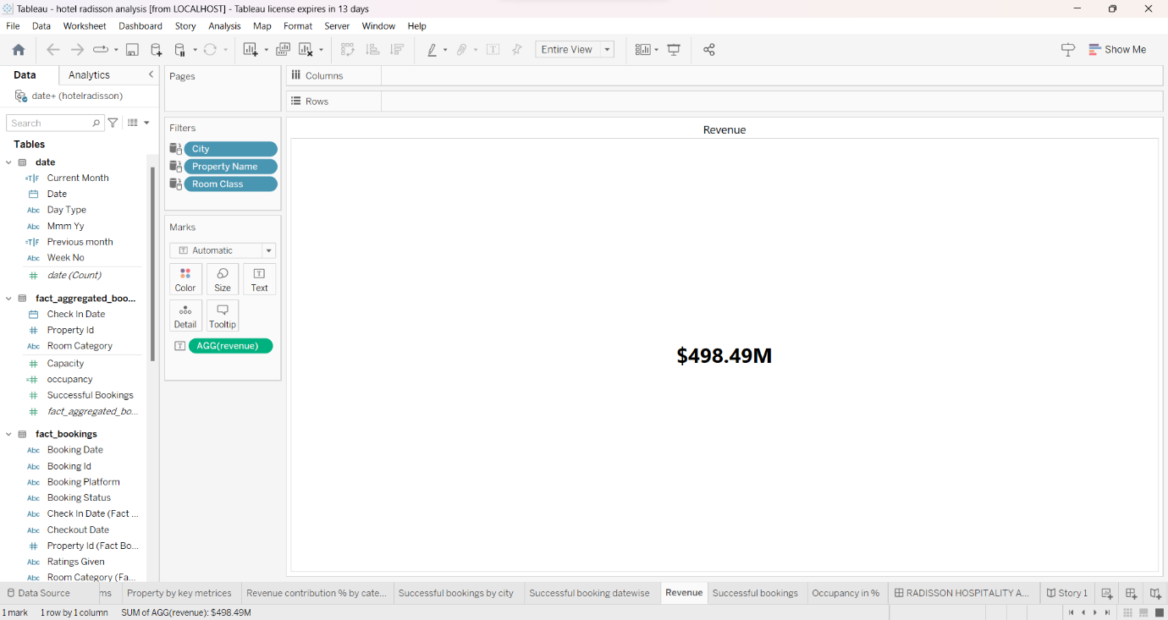
* SUCCESSFUL BOOKINGS: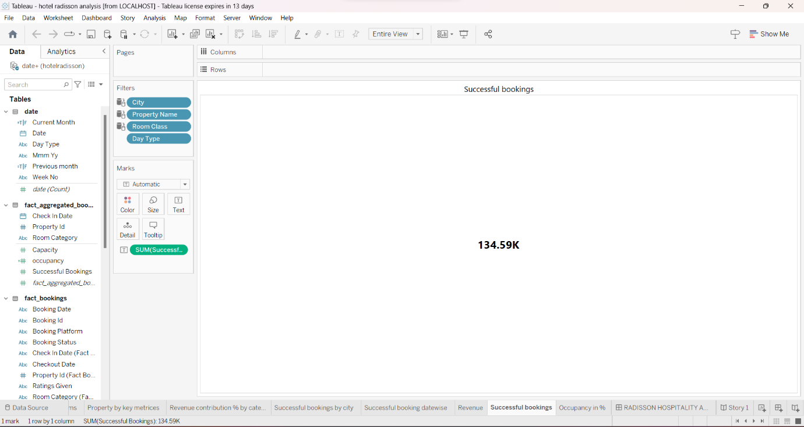
* OCCUPANCY IN %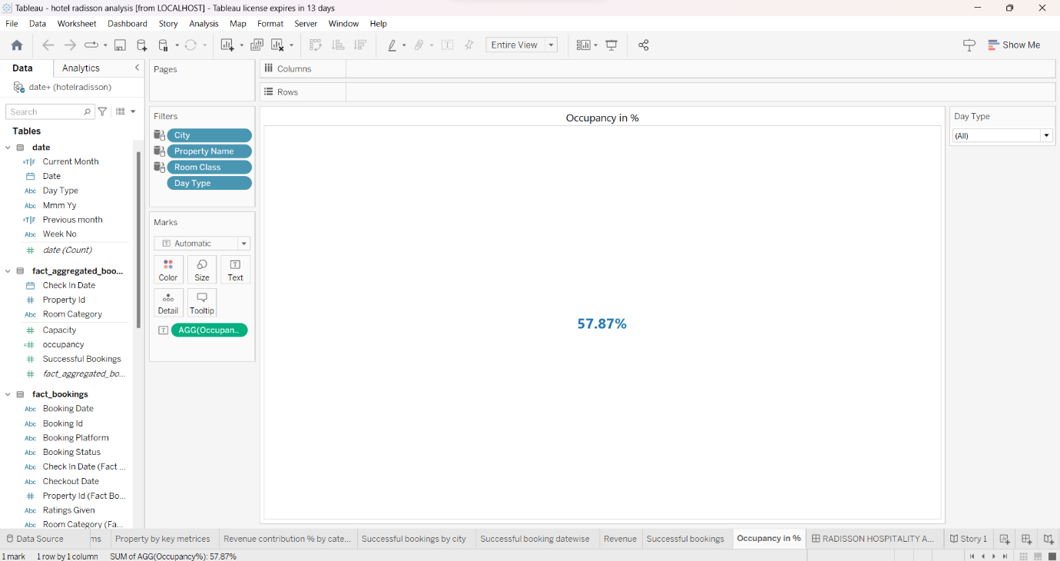

DASHBOARD:

RESPONSIVE AND DESIGN OF DASHBOARD:

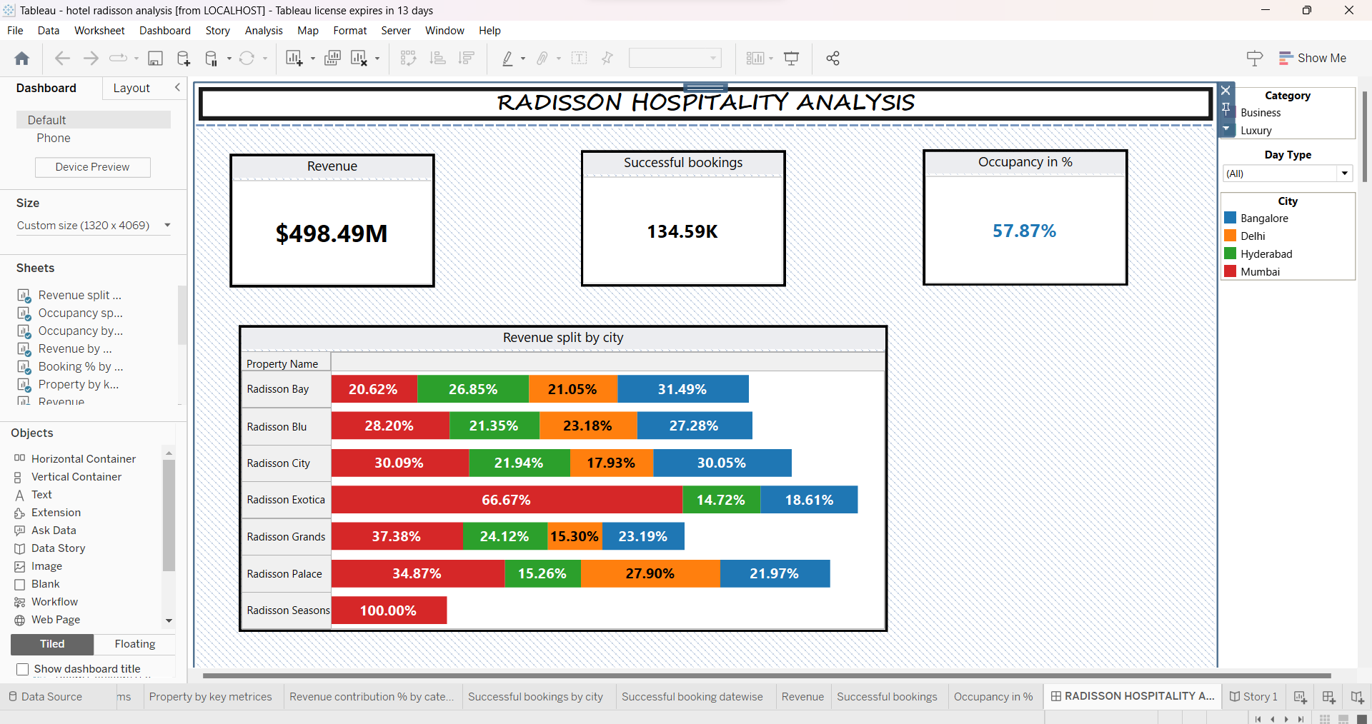

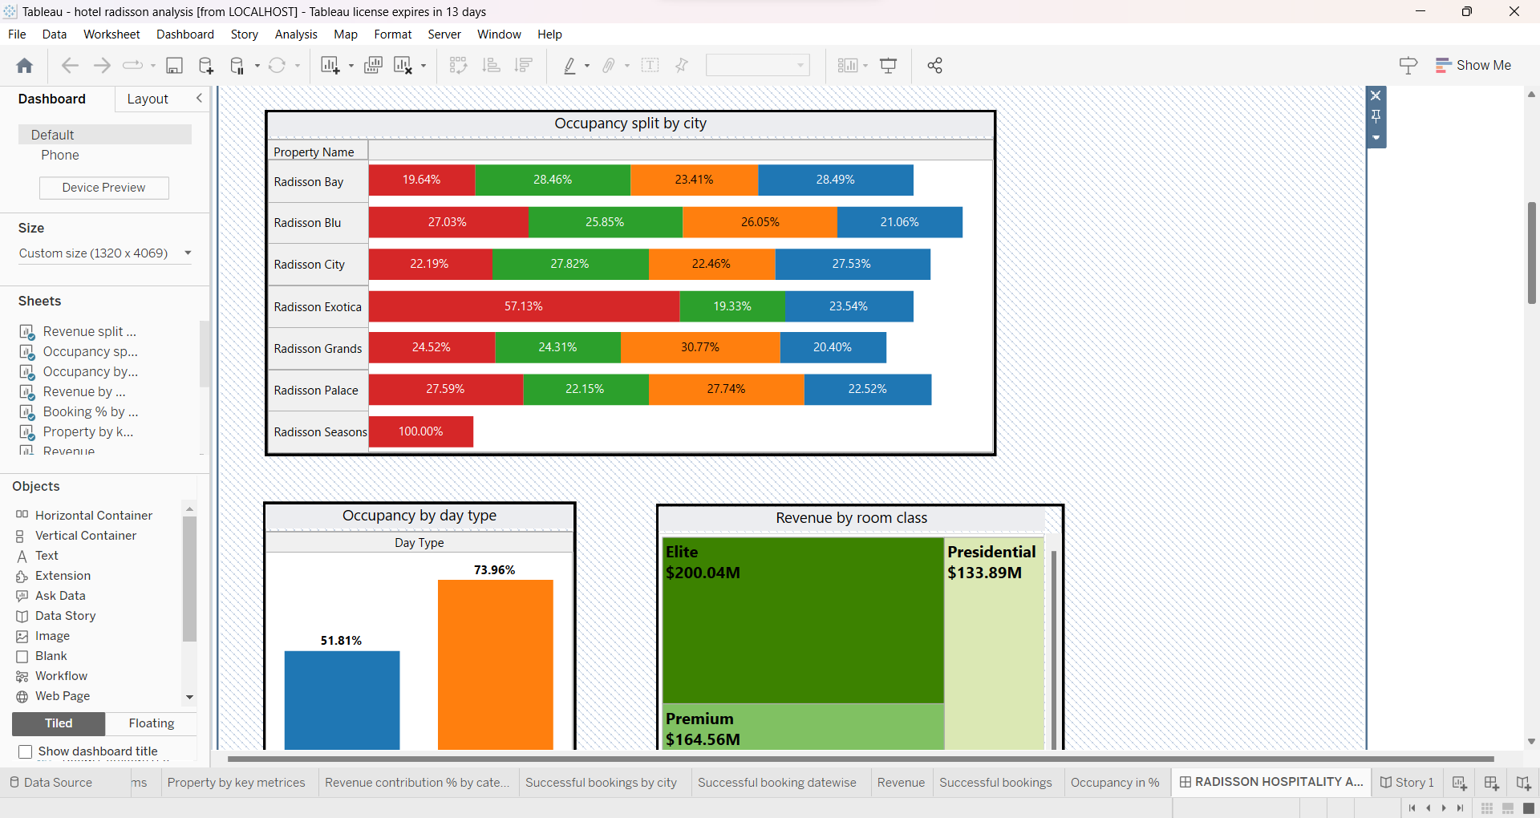

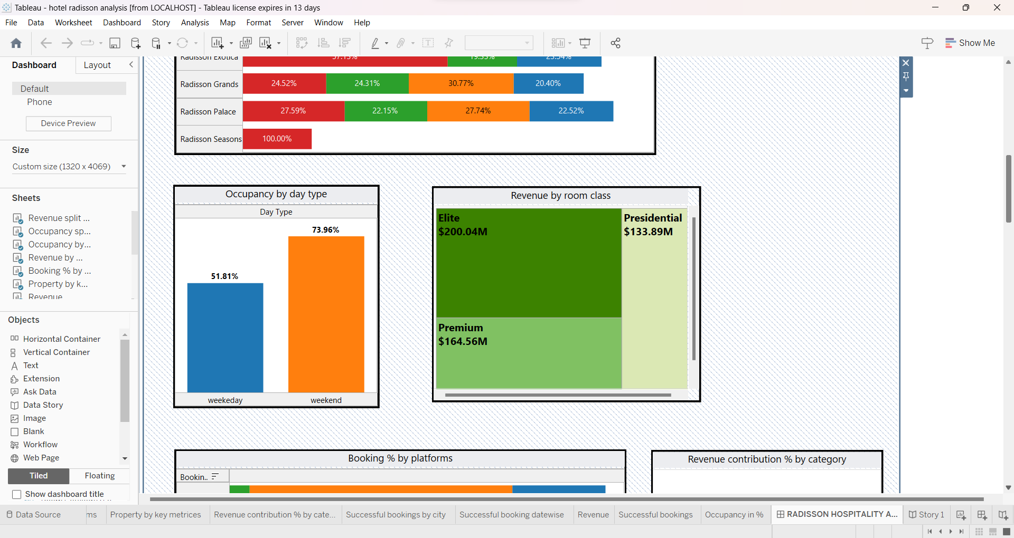

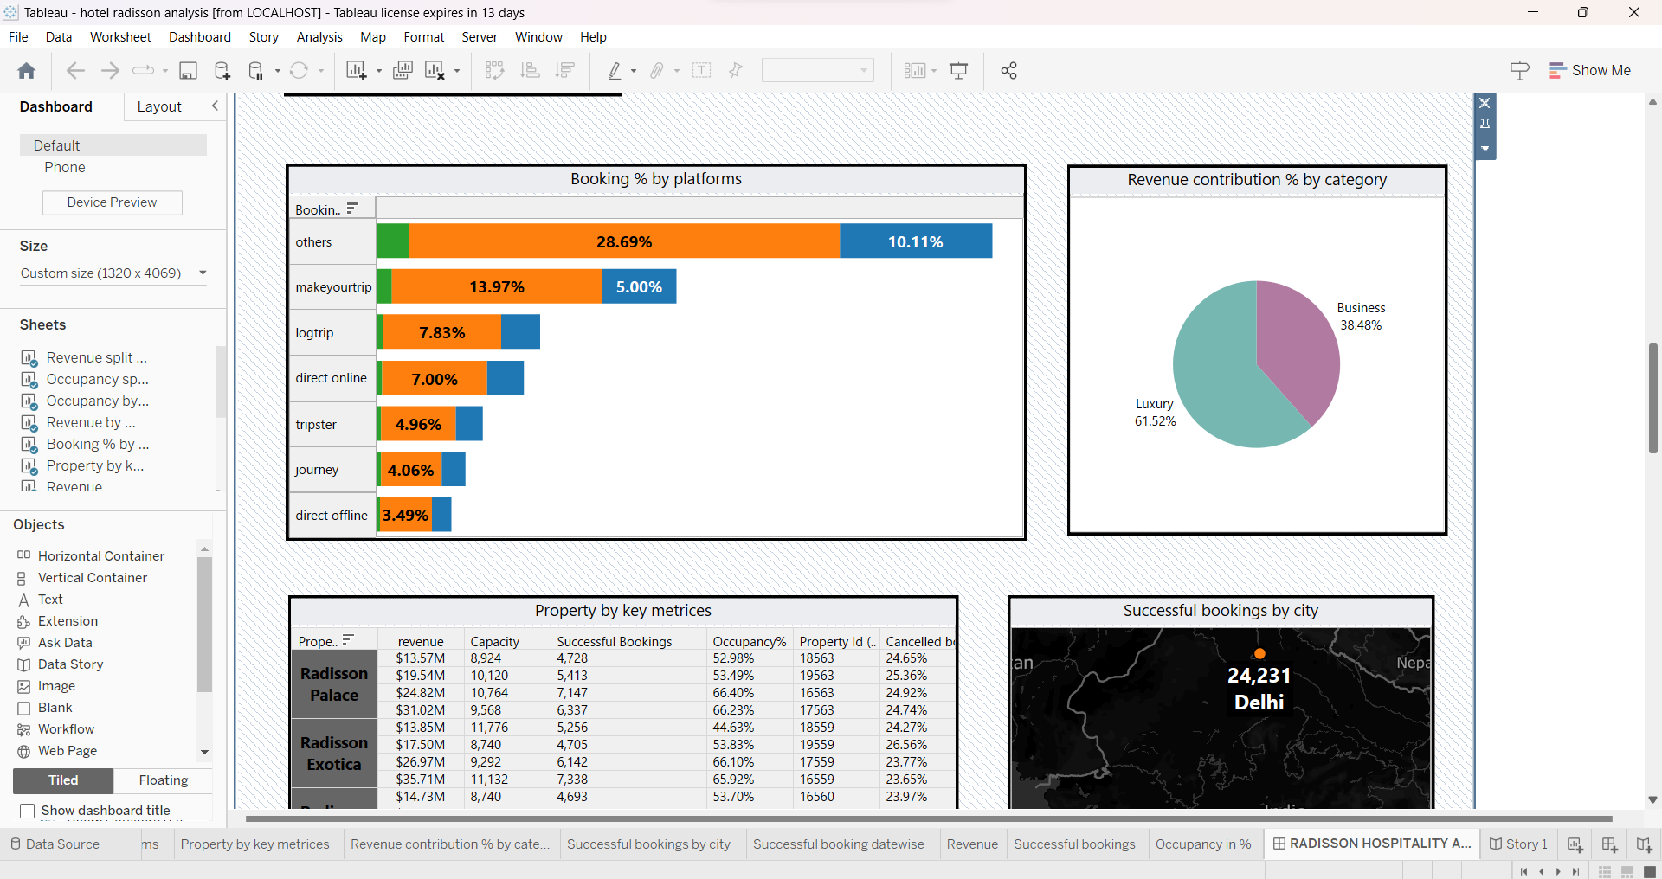

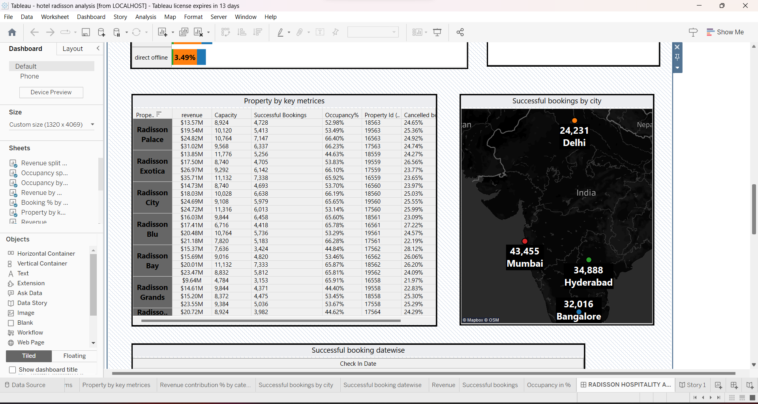

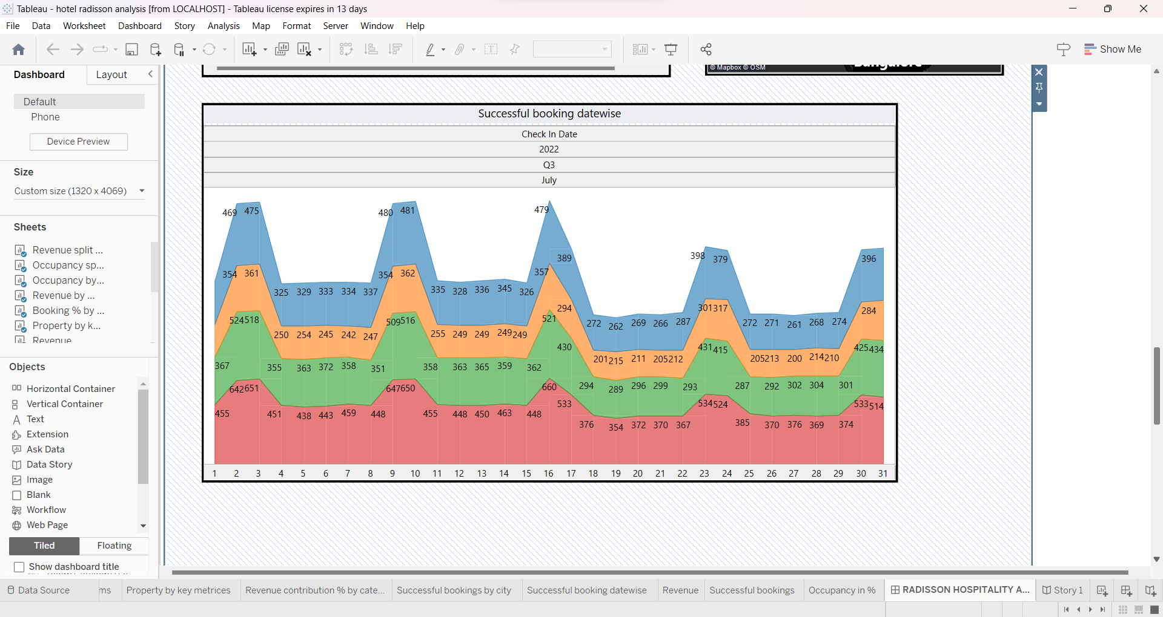

STORY:

A data story is a way of presenting data and analysis in a narrative format, with the goal of making the information more engaging and easier to understand. A data story typically includes a clear introduction that sets the stage and explains the context for the data, a body that presents the data and analysis in a logical and systematic way, and a conclusion that summarizes the key findings and highlights their implications. Data stories can be told using a variety of mediums, such as reports, presentations, interactive visualizations, and videos. The story highlights of the Radisson hotel visualizations are provided below.

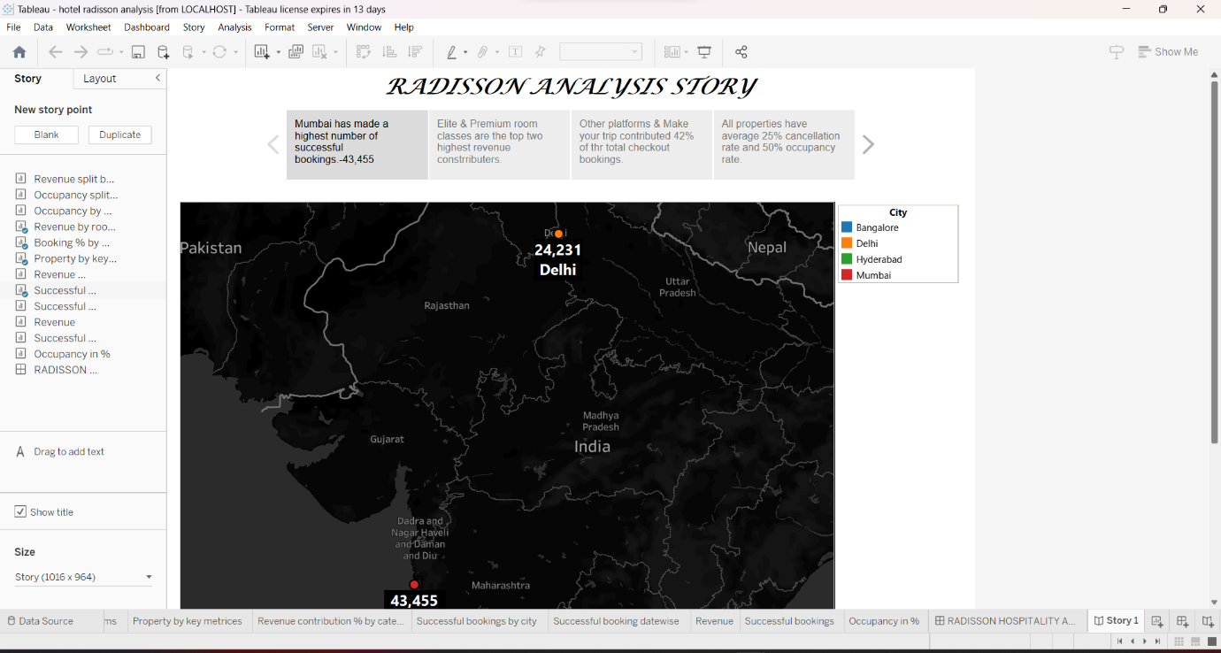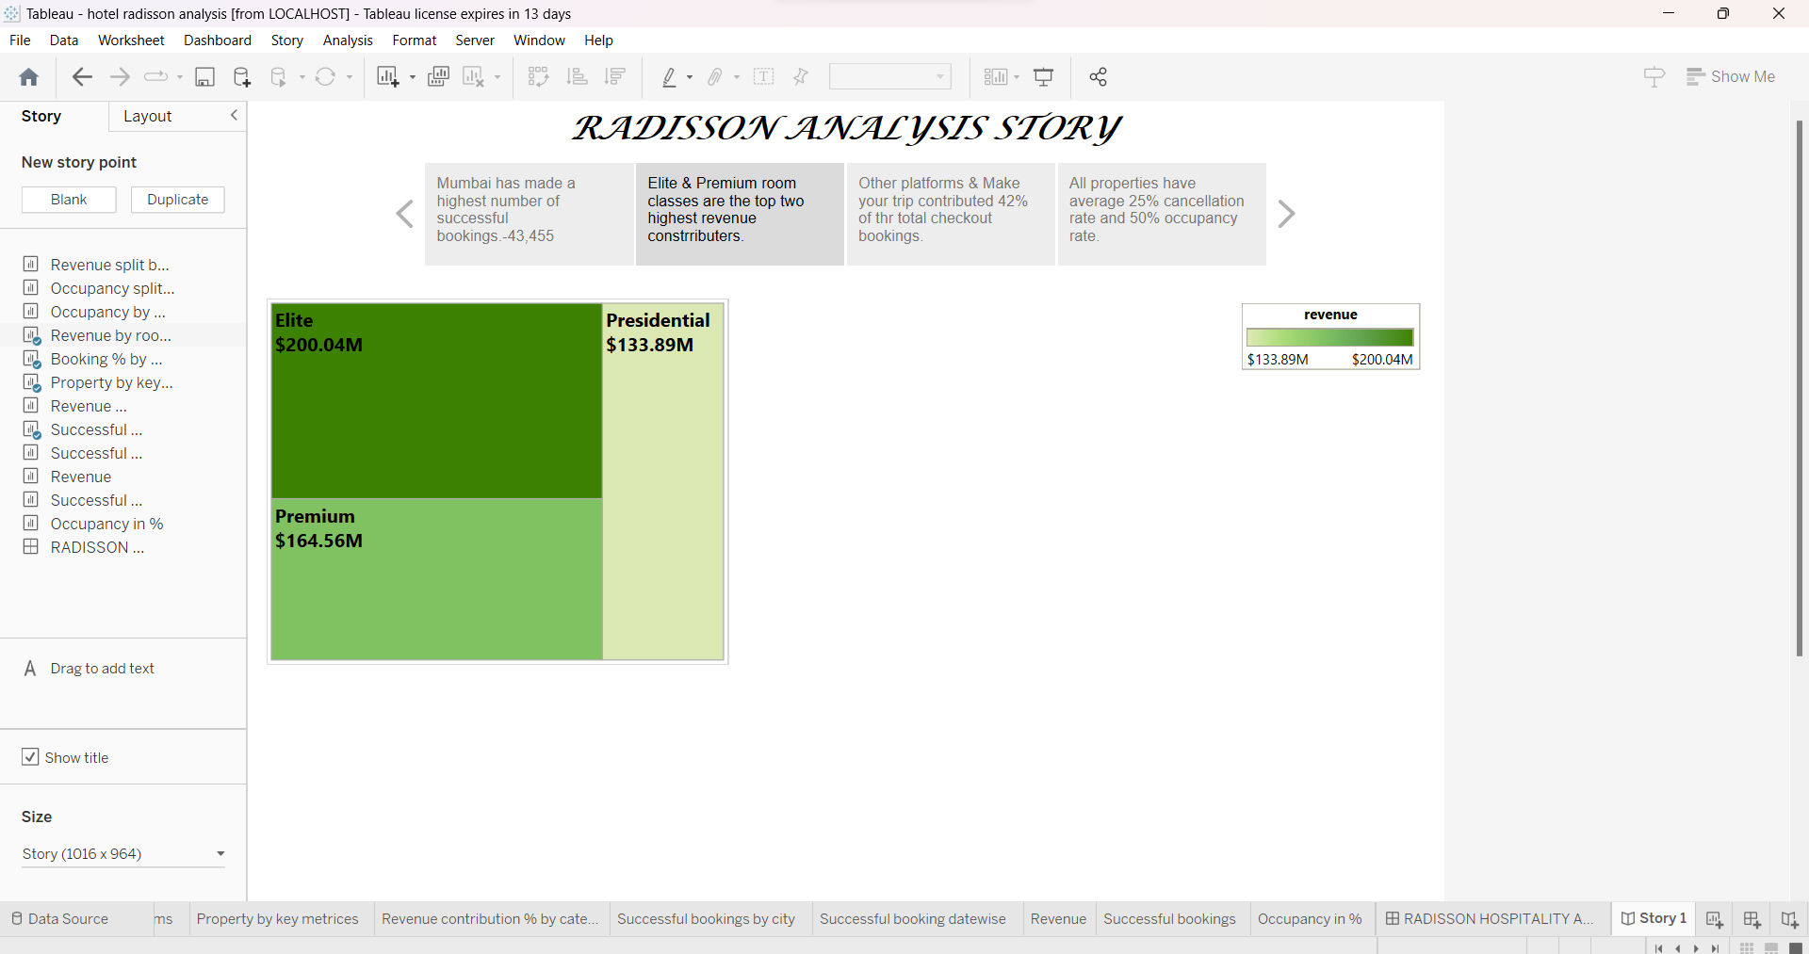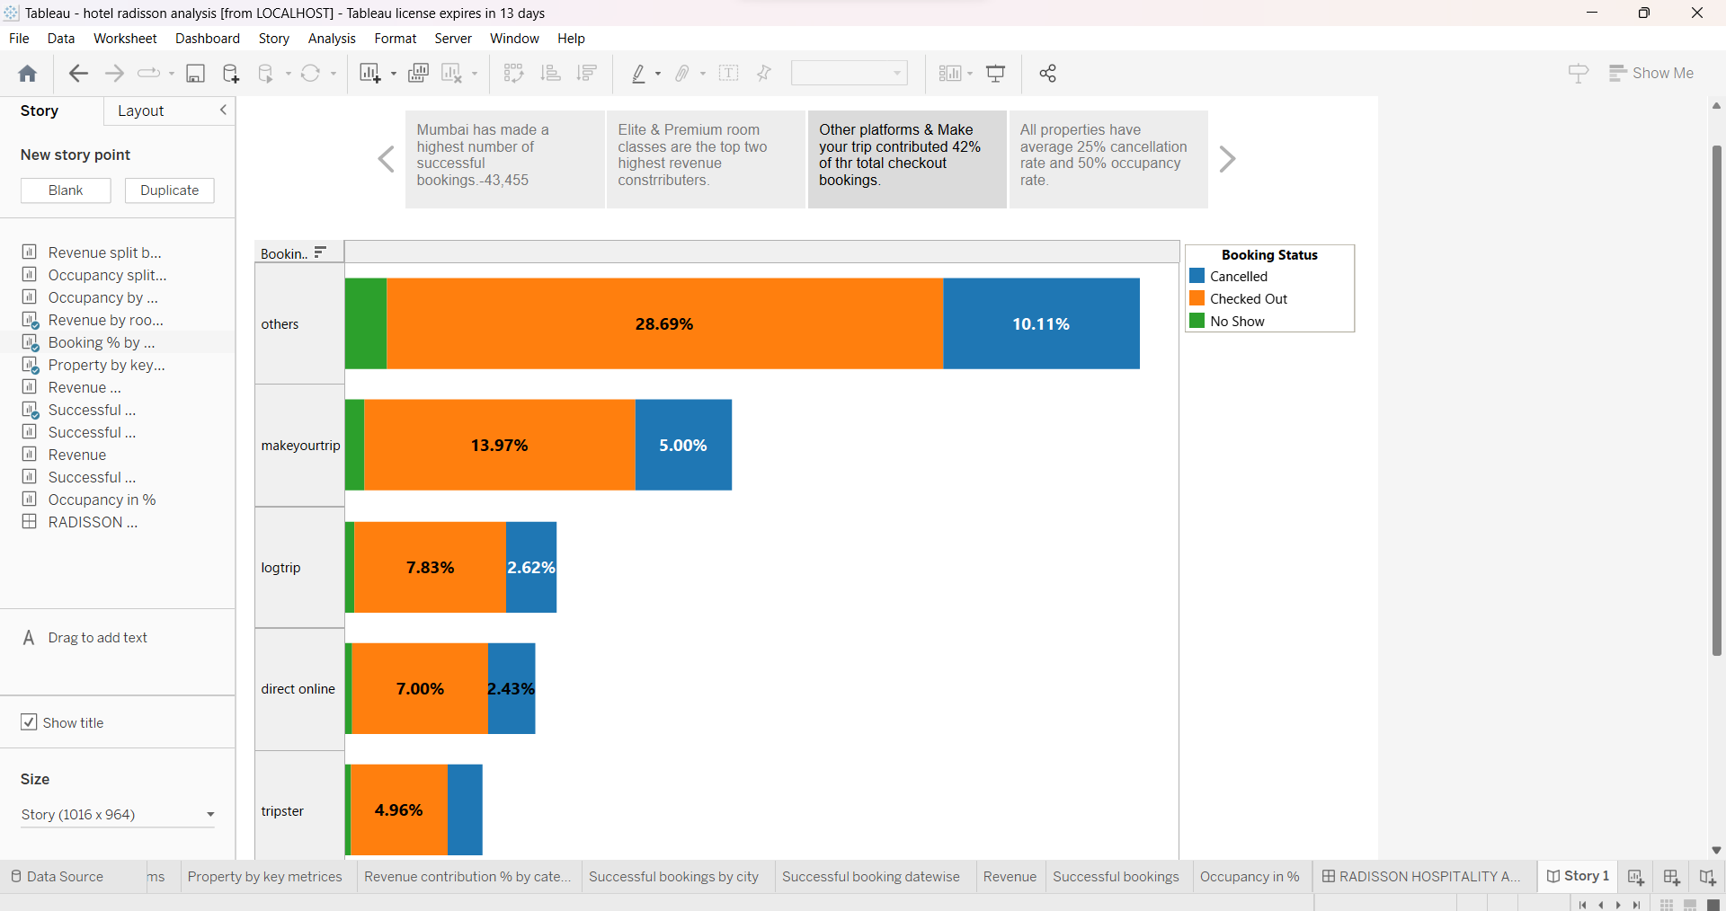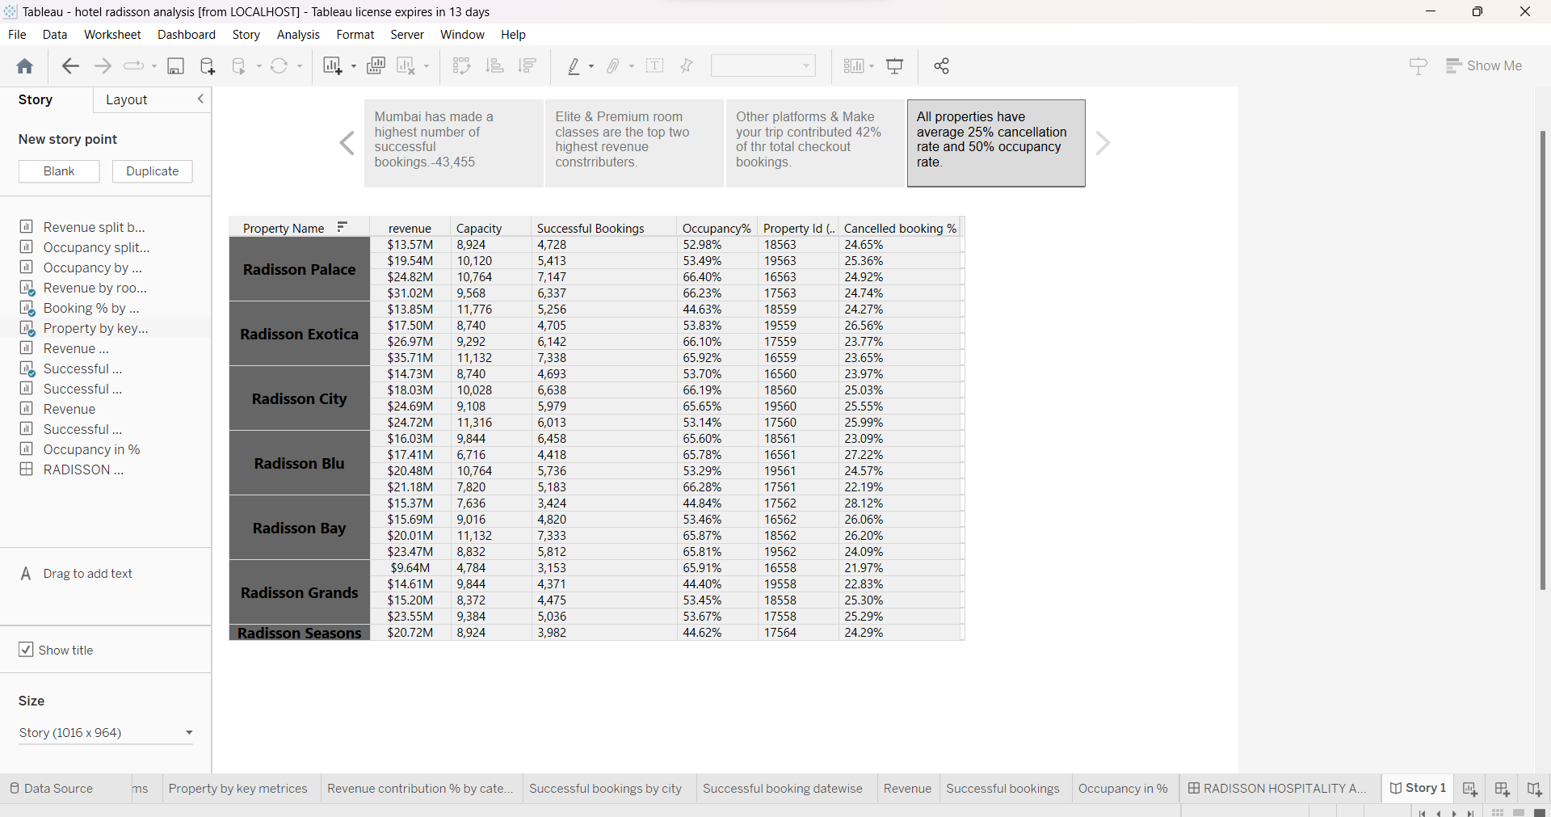

Hence these are the results and the final findings of the project on analysing the efficiency and performance of the radisson hotels on data vizualisation techniques.

ADVANTAGES AND DISADVANTAGES OF ANALYSING THE PERFORMANCE AND THE EFFICIENCY OF THE RADISSON HOTELS USING DATA VISUALIZATIONS:

ADVANTAGES:

* The main advantage of efficiency measured by the DEA over other performances measurement indicators is that it can evaluate multiple dimensions.
* The multiple dimensions works can be done eventually without any interuption.
* Easy to monitor all networks form a single network
* Effectively notes the profits, loss, and the satisfaction of the customers worldwide.
* Can be easily managable, the performnce and the efficiency are eventually increasing by using the data visualization techniques.

DISADVANTAGES:

* The hotel industry not only produces large amount of waste and carbon dioxide, which contribute to climate change but also consmes a lot of energy and water.
* Long working hours.
* Lots of physical labour.
* No festival holidays
* Work may get stressful
* Additionally less flexibility .

APPLICATIONS:

Gone are the days when having a personal computer or a smartphone connected to the Internet conferred bragging rights. Digital technology is getting more and more accessible, influencing how people work, relax, and plan their vacations. People’s expectations for a hotel experience have grown and hoteliers had better keep pace with innovation. Let’s imagine you have to choose between two hotels offering rooms for the same price. The former provides facial recognition check-in and a chatbot that answers your questions in a couple of seconds, while the latter has only comfortable rooms to offer. What hotel would you book? The answer is obvious.

The previously mentioned features are based on AI and data science. We talked with data scientists, start-ups, and hotel representatives to find out how hotels use AI and data science to evaluate their performance and provide an innovative guest experience.

## **1. Revenue management**

[Revenue management](https://www.altexsoft.com/blog/datascience/machine-learning-redefines-revenue-management-and-dynamic-pricing-in-hotel-industry/) (RM) is the application of data and analytics to optimize product price and availability for maximum revenue. In other words, a [revenue management specialist](https://www.altexsoft.com/blog/business/hotel-revenue-management-solutions-best-practices-revenue-managers-role/#revenue-manager-job-description) is looking for ways to sell the right product (i.e. a room) via the right distribution channel, for a reasonable price to a customer who is ready to buy.

Specialists monitor various metrics to understand how successful a property is compared to others in the same price range and type in a given area. The number of key performance metrics is extensive and includes such indicators as average daily rate (ADR), revenue per available room (RevPAR), average occupancy rate, gross operating profit (GOP), and gross operating profit per available room (GOPPAR).

Calculating and analyzing these performance metrics data, revenue managers can forecast room demand and customer behavior to adapt room prices. This approach is called dynamic pricing.

### **Dynamic pricing automation**

Data science allows hotels to predict demand and patterns of customer behavior more accurately. That’s why global chains such as Marriott International and AccorHotels [have data scientists and analysts on board](https://revenueanalytics.com/news/future-revenue-management-data-analytics-big-investments/). These specialists develop and deploy pricing models using data about hotels and their competitors.

Some hotels rely on RM solutions to be in control of their revenue. Such software defines the optimal room rate in real-time using machine learning. These RM systems automatically consolidate and analyze large amounts of internal and external data from multiple sources to detect patterns and anomalies.

One such solution, the [OTA Insight](https://www.otainsight.com/) platform, for example, is used by Carlson Rezidor, AccorHotels, Fusion Hotels and Resorts, Sydell Group, Hilton, Crowne Plaza, and other global and regional hotel brands.

The platform includes three modules, each of which is designed to solve a specific revenue management task.

**Parity Insight** compares rates on the main OTAs and metasearch engines with the ones on a hotel brand website to identify parity issues. For instance, hotels with consistent rates on both an online travel agency and their own site can reduce their dependency on it and avoid guest confusion.

**Revenue Insight** combines past and future performance to provide users with “smarter hotel analytics.” The platform consolidates reports on hotel KPIs, allowing for a quick and easy year-over-year performance comparison.

## **2. Operational analytics**

The hospitality business doesn’t know what a day off or a holiday is, which means hotel software systems work without a second-long break generating all types of guest and operational data. Whether someone books a room or orders a Caesar salad in a restaurant, a housekeeper alerts about a lack of cleaning supplies, or an event manager reserves a conference room, a property management system captures this data.

Real-time observation of internal processes done through operational analytics allows hoteliers to find missteps and look for ways to improve. Businesses may conduct a competitive analysis, forecast customer behavior for each season, monitor brand mentions and reputation on social media by analyzing feedback, or determine why website users start bookings but don’t complete them (churn analysis). The number of data science applications depends on IT infrastructure and staff skills.

### **Performance evaluation**

With data visualization tools, hotels are able to collect relevant operational data across departments to monitor, evaluate, and improve their performance. A hotel group from Texas utilizes iDashboards to gain organizational transparency, the company representative shares. “The staff members were operating on old data, and those old reports caused a disconnect between daily job performance and the bottom line. They use the software in their sales department – tracking rooms, events, and referrals. The hotel can now correlate a revenue amount to the referral program. Additionally, employees can take ‘ownership’ with the dashboards by showing how their specific jobs impact the organization.”

### **Competitive analysis**

Competitive analysis of customer feedback on social media allows hotels to understand who their customers are, what they think makes a perfect guest experience, and what customers feel about staying in a hotel. What’s more important, hoteliers can learn why people evaluate a brand in a certain way. In this regard, AI is here to capture and process feedback with a speed and accuracy a human isn’t capable of achieving.

## **3. Hotel energy consumption management and predictive maintenance with IoT solutions**

Working all year-round, hotels are among the [top five facilities based on energy consumption](https://www.e-unwto.org/doi/book/10.18111/9789284414970) in the tertiary building sector. On average, hotels in the US spend nearly [6 percent](https://www.energystar.gov/sites/default/files/buildings/tools/SPP%20Sales%20Flyer%20for%20Hospitality%20and%20Hotels.pdf) of all operating costs to pay for utility bills. The positive thing is that energy expenses can be controlled via energy management. Modern approaches to energy consumption have gone far beyond the installation of energy-saving lighting systems, changing building standards, or the use of information cards in bathrooms.

### **Consumption management**

Hotels move towards energy efficiency with cloud-based software. Smart energy management platforms supported by IoT devices gather real-time information on energy usage and monitor temperature, humidity, air pressure, and air quality inside the building. This software can also track weather data and utility rates, while monitoring occupancy to adjust the work of HVAC (heating, ventilating, and air conditioning) and lighting systems. As a result, these systems provide property owners with energy use patterns – energy profiles. Received information helps hoteliers understand where they can use fewer resources to achieve energy efficiency goals. The access to data is usually available from both desktop and mobile devices.

## **4. Customer experience improvement**

When people go on vacation to take a break from their fast-paced lives, they demand that any problems are solved as quickly as possible. Travelers want to enjoy a comfortable stay while seamlessly accessing all the pleasures a hotel has to offer.

### **Messaging automation**

Harris Interactive market research agency conducted a [study](https://onereach.com/resources/high-demand-for-text-message-2014-report) on behalf of OneReach and found out that 64 percent of consumers who can choose between texting and voice as a customer service channel would prefer the former. In addition, 44 of respondents with texting capabilities would rather press a button to start messaging instantly than wait for a customer service agent to respond.

Hotels that adopt messaging support with AI-backed virtual assistants can enhance guest satisfaction by making them feel welcomed and taken care of.

### **Guest service with a robot’s help**

Some are afraid that robots will completely replace humans and leave them without jobs. As for today, these smart machines free human employees from routine tasks like housekeeping, room service, and concierge services.

Crowne Plaza in San Jose, for instance, delights guests with Dash, the robot. Dash delivers food, toiletries, and provides information on hotel amenities and attractions. The robot independently moves around the property and can even call the elevator using a Wi-Fi connection. Dash calls a guest before coming to the door, delivers the desired items, and goes back to the lobby. The robot also tracks its power usage and connects itself to a charging station when needed.

[Botlr](http://www.hoteliermiddleeast.com/30638-aloft-hotels-introduces-robot-butlers/) is another robot servant that helps staff in Aloft Hotels. Guest can send requests about snacks, towels, or whatever simple things they need via the SPG app on their smartphones, and Botlr will quickly deliver them.

## **Opportunities for data science in the hotel industry**

With AI and data science, hotels have advanced tools to evaluate and improve performance. Hotels use operational analytics to find more efficient ways of spending their resources, reduce energy consumption, introduce and develop revenue management strategies, as well as automate staff workflow with smart virtual assistants.

“There are department-specific opportunities but from a broad approach data science can be used to find correlations and improve operational efficiencies,” notes Andrew Gissal from iDashboards.

Data science that provides tooling for the guest service operation can be further extended to enable the guest and management to better control the entire hotel experience, thinks Go Moment CEO Raj Singh.

6) CONCLUSION:

The project on ANALYSING THE PERFORMANCE AND EFFICIENCY OF RADISSON HOTELS BY USING DATA VISUALIZATIONS TECHNIQUE helps us to understand the brief concet about the hotel management.

The project visualises the wide impact on the brainstoming and the empathy maping in the broad manner whooch helps to study te impacts in deep. By the use of the software MYSQL helps to maintain the datas. The TABLEAU helps to study various hotel applications by splitting up into various broad datas separating into cities, manners, bookings etc. The datas helps to study under various categories of the hotel studies and to enhance the futher ideas of the hotels. The data visualizations helps to maintain the datas and the reduces the future complications and maintain the performance and the efficiency of the hotels in the best manner. Hence the conclusion of the project on analysing the performance and efficiency of radisson hotels by using data visualization techniques.

7.FUTURE SCOPE:

### 1. Sustainability is the New Normal

If we consider the U.S. workforce, millennials have officially taken over the U. S workforce. Moreover, the reign will last till 2034. At that point, Gen X will see full-scale employability (reaching up to 78 million). So, it is not a wise idea to ignore them. One of their top demands is that hotels go green.

As per Diana Verde Nieto, co-founder and CEO of Positive Luxury,

*“Millennials are twice as likely to support brands with strong management of environmental and social issues, and expect brands to not only manage their impact but communicate it.”*

Let us have a look at some of the statistics that support our claims.

* 55% of global travelers want to choose sustainable accommodation, but the lack of appealing options makes it difficult.
* 87% of millennials believe that business success is proportional to its impact on the world. Millennials have a hard time trusting businesses.

Thus, the future of the hotel industry involves sourcing food from local farms, monitoring the use of water, and removing single-use plastics from dining centers and restaurants.

### 2. Global Outlook

Well, local events and targeting a specific set of audiences is great; the hotel industry needs to think on a global scale.

As per [global hotel studies](https://str.com/landing/global-hotel-study-report), the industry is set to witness an increase in tourist destinations; previous generations had not even considered.

The demand for international travel is flourishing, causing top airlines to add more direct flight routes to foreign countries. Ignoring the effects of globalization can be detrimental to your hotel’s health. A possible solution for this is to have both localized management teams and an oversight hub to boost international expansion.

Besides, events and meetings no longer need to be local. International venues are eager for more group sales, and attendees will be more than willing to travel than ever.

**3. Old Threats and New Inspiration**

Besides, the travel giant even partnered with Century 21 and positioned itself as a real-estate leader. So while in the past, hotels considered Airbnb as a threat, things are changing at a fast pace.

But, what is actually happening?

Pressure from these giants is pushing hoteliers to adopt better practices and providing better customer experiences.

As Airbnb continues to expand into hotels, more hotels are expected to continue to foray into home-sharing, which means 2x more opportunities!

More hotels will realize that working in tandem with giants is a great [hotel marketing strategy](https://www.softwaresuggest.com/blog/hotel-marketing-strategies/) and will make way for better offerings.

The coming years will see a balanced distribution among leisure-focused Airbnb and hotels moving towards home-sharing to satisfy group demands. As the shift to the new marketplace happens hotels, will be able to reap more profits.

### 4. Addressing Peak Demands

There will be a significant [increase in hotel bookings](https://www.softwaresuggest.com/blog/marketing-tips-for-hoteliers-to-increase-hotel-bookings/) in the coming years. Here is what Jim Chu, the Global Head of Development & Owner Relations, Hyatt Hotels Corp has to say.

*“Be aggressive. Continue to move forward. We’ve never had this demand from all directions.”*

United States Commercial Real Estate Services (CBRE) forecasts consecutive [growth for the U.S. hotel industry through 2022-2026](https://www.cbre.us/research-and-reports/2021-US-Real-Estate-Market-Outlook-Hotels). Besides, the hotel market will see steady growth in the future.

The future hospitality trends look overwhelmingly positive, and hotels are investing heavily in construction and renovations. Hotels will also witness healthy competition and adopt the smarter way to become customers’ favorites.

### 5. Increased Use of Social Media for Promotion

Unfortunately, many hotels are lagging as they are not using social media to promote their hotel services. It is not only a great marketing medium, but it also helps you cater to a diverse set of customers at the same time. These include youth, influencers, and corporate business travelers.

The future of the hotel industry will see more hotels using social media as customer care and driving revenue. This means you will get more opportunities to engage with your customers when they visit your social media channels. These interactions will help you build brand awareness and customer loyalty.

The modern online customer shares their travel and destination experience on [social media platforms](https://www.softwaresuggest.com/blog/which-social-media-platform-is-the-best/). These social media platforms will act as a reference for people planning their vacation, looking for the best stays, and finding out the exciting menus.

Thus, with time hotels have new avenues to interact with customers, make interesting offers and build long-term relationships.

### 6. Rise in Video Marketing

Video marketing is becoming a popular medium for hotels. In the future, hotels will be able to attract 80% of guests with video engagement.

Videos are a popular medium to highlight the specialties of your hotels and restaurants. You can even use it to give your customers a preview of what facilities you will provide beforehand.

For example, you can attract guests with videos of delicious cuisines and share videos of smart rooms to make them visit your hotel. Besides, 64% of users are likely to book rooms after watching a video.

Thus, the future of the hotel industry will see hoteliers creating custom videos and engaging in innovative ways to retain customers.

Hence these are the future scopes of the hotel industries.

Hence the future scopes and the project on the analysing the performance and the efficiency of the radisson hotels by using data visualization techniques.

Demonstration video: [video_20230519_155249.mp4 - Google Drive](https://drive.google.com/file/d/1xGKEZkV2vduPlhsrt_-UrbofnRjbE7Zn/view)

Thank you….!!!!!!